ARCHITECTURE DESIGN
Emergency Shelter Allocation Platform
A Nationally-Scalable, Multi-Hazard Disaster Shelter Allocation System — Pilot: Assam (Flood Response)
Review 1 | Course: CSS7102 | Presidency University
Team: Sharan (Team Lead), Harshil Gurjar, Suhas | Guide: Mr. Irfan Rajab Bhat
29 August 2026

1. Design Philosophy
The platform is built around one architectural bet: the same pipeline — find candidate shelters, score them for safety, calculate distances, optimise who goes where, persist the result, and visualise it — should run unchanged for any Indian state and any hazard type. Only the data sources feeding the pipeline and the suitability rules applied inside it change per deployment. This is deliberately architecture-first, data-second: Assam flood response is this project's fully validated pilot, not a hardcoded assumption baked into the code.
Three decisions define this architecture, each justified in more depth in Section 6: (1) shelter discovery is kept completely separate from allocation, because that mirrors how real disaster response actually works — you must know where safe shelters exist before you can decide who goes where; (2) one hazard-pluggable scoring interface is used instead of three duplicated pipelines for flood, cyclone and earthquake; and (3) every external dependency — routing API, building metadata, internet connectivity — has a documented fallback, because a disaster-response tool that fails the moment connectivity or data is imperfect is not fit for purpose.

2. The Eight-Stage Pipeline
Every disaster response the system handles moves through the same eight stages, tagged throughout by a single event_id created in Stage 0. The pipeline is deliberately drawn as a loop below: Stages 0–3 establish context and discover supply and demand; Stage 4 is the optimisation core; Stages 5–7 persist, visualise and expose the result to a human coordinator.
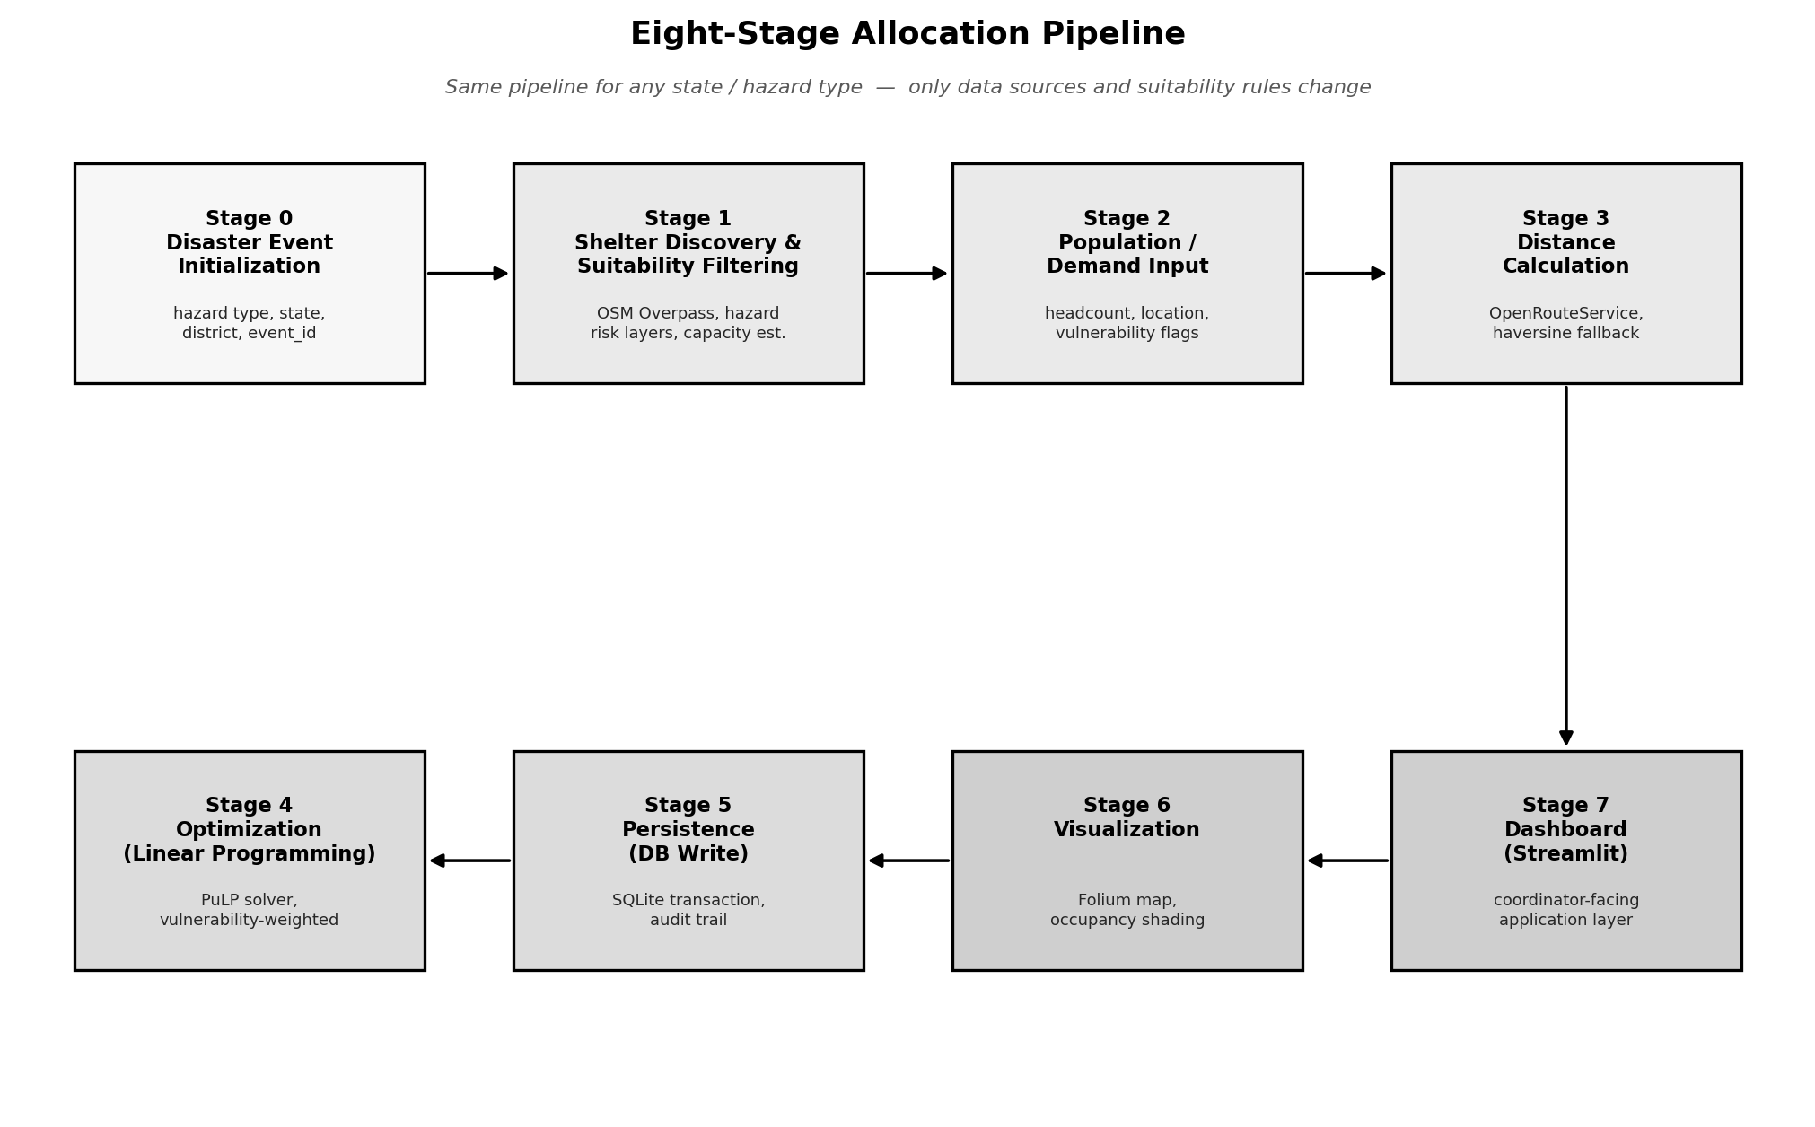
Figure 1. The eight-stage allocation pipeline, shown as a continuous flow from event creation through to the coordinator-facing dashboard.
Stage | Name | What Happens
0 | Disaster Event Initialization | Coordinator specifies hazard type, state, district, start date; a unique event_id is created and tags every downstream record, so multiple simultaneous disasters never interfere with each other.
1 | Shelter Discovery & Suitability Filtering | Overpass API pulls candidate buildings from OSM; hazard-specific risk data is retrieved (flood inundation/DEM, cyclone buffers, seismic zones); each candidate is scored and capacity is estimated from its footprint.
2 | Population / Demand Input | Displaced-group records (location, headcount, vulnerability flags) are entered or uploaded and tagged to the active event_id, with status = pending.
3 | Distance Calculation | OpenRouteService computes real road-network distance/time from each group to each candidate shelter; falls back to haversine straight-line distance (flagged 'estimated') if ORS is unreachable; only the top-N nearest shelters per group are retained.
4 | Optimization (Linear Programming) | PuLP builds and solves a linear program minimising total distance, subject to capacity and full-assignment constraints, with vulnerability-weighted priority; unmet demand is reported explicitly as a waitlist rather than silently overcrowding shelters.
5 | Persistence (Database Write) | Each allocation, the shelter's updated occupancy, and the group's updated status are written inside one SQLite transaction, so a failure partway through never leaves the database inconsistent.
6 | Visualization | A Folium map is regenerated live from current database state: shelters colour-coded green-to-red by occupancy, group origins, allocation lines, and unallocated/waitlisted groups marked distinctly.
7 | Dashboard (Streamlit) | Ties every stage into one interface: event selector, population data view, suitable-shelters map, a single 'Run Allocation' button (triggers Stages 3–5), results view, and a backtest view against the real Assam flood event.

3. The Five-Layer System Architecture
Orthogonal to the pipeline view, the system is also organised into five logical layers, each independently upgradeable as the project moves from prototype to production without touching the layers above or below it.
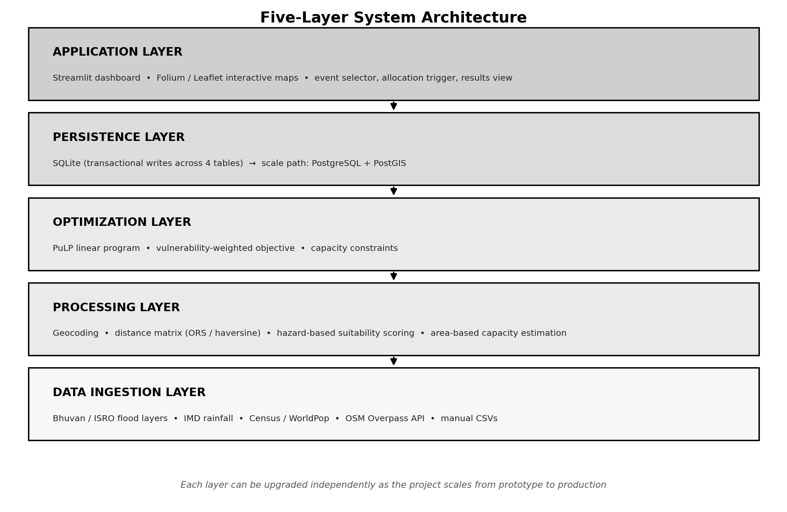
Figure 2. Five-layer architecture — data flows downward from raw government/OSM sources to the coordinator-facing dashboard.
Layer | Prototype (Now) | Scale-Up Path (Future)
Data Ingestion | Bhuvan flood layers, IMD rainfall, Census/WorldPop, OSM Overpass, manual CSVs | Scheduled ingestion jobs from live government APIs
Processing | Geocoding, distance matrix, hazard-based suitability scoring | Same, with richer building/structural datasets
Optimization | PuLP linear program, vulnerability-weighted | Same core algorithm, larger-scale solvers if needed
Persistence | SQLite (3+ tables, transactional writes) | PostgreSQL + PostGIS for geo-indexed queries at scale
Application | Streamlit dashboard, Folium maps | Web + mobile app, offline-first sync

4. Database Schema
Four tables anchor the entire system. Every population group and every shelter search traces back to a disaster_events row through its event_id; every allocation is an immutable audit-trail row linking exactly one population group to exactly one shelter.
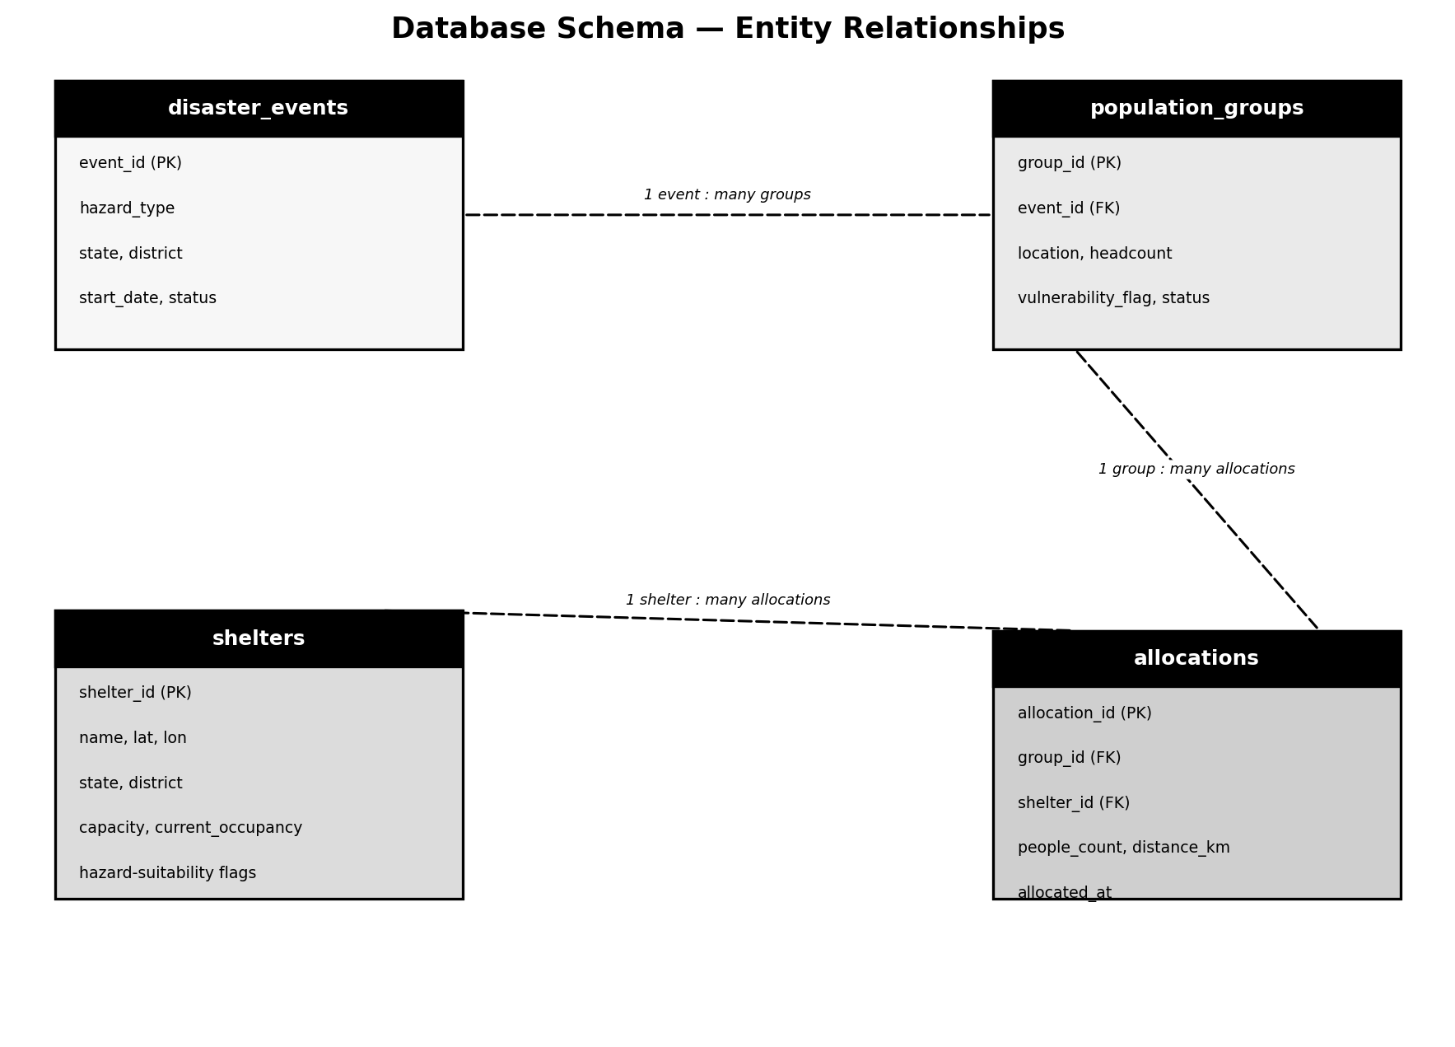
Figure 3. Entity-relationship diagram — dashed lines show the foreign-key relationships that tie every table back to a single disaster event.

5. Why This Architecture: Design Justifications

5.1 Why separate shelter discovery from allocation (Stage 1 vs. Stage 4)?
Because that is how real disaster response works. A coordinator must first know which buildings are safe before deciding who goes where; conflating the two into one step would mean re-solving 'is this building safe' every time the population numbers change, which is wasteful and, more importantly, risks silently trading safety against convenience inside a single black-box score.

5.2 Why a linear program (PuLP) instead of a simple nearest-shelter heuristic?
A greedy nearest-shelter assignment can fill up the closest shelter first and then strand later groups far away, or blow past a shelter's capacity. A linear program finds the assignment that minimises total distance across all groups simultaneously, subject to hard capacity constraints, and can encode vulnerability weighting directly in its objective function — which a simple heuristic cannot do without ad-hoc patching.

5.3 Why SQLite now, PostgreSQL + PostGIS later?
SQLite needs no server process, ships as a single file, and fully supports the transactional writes Stage 5 depends on — ideal for a single-instance prototype built and demonstrated within one semester. It is an explicit, documented limitation (Section 8) that it is not appropriate for concurrent multi-user, multi-district production use, which is exactly what the Phase 2 migration to PostgreSQL + PostGIS is planned to address.

5.4 Why one pluggable hazard-scoring function instead of three separate systems?
Flood, cyclone and earthquake suitability all reduce to the same shape of problem — retrieve a hazard-specific risk layer, then discard or downrank candidate buildings against it. Writing this once as a dispatcher that calls a hazard-specific sub-function keeps the codebase maintainable as more hazards are added, instead of three parallel codebases quietly drifting apart over time.

5.5 Why Streamlit for the coordinator-facing dashboard?
Streamlit turns a Python data pipeline directly into a usable web interface without a separate frontend build, which matters for a small team validating a prototype within one semester. It renders Folium maps natively, which is what makes Stage 6 and Stage 7 a thin, low-effort layer on top of Stages 0–5 rather than a second, separately engineered application.

6. Map & Geospatial API Integration — Why No Google Maps
A question this architecture is built to answer cleanly: Google's Maps Platform (Maps JavaScript API, Places API, Directions API, Distance Matrix API) is metered and billed beyond a limited free credit, which is a poor fit for a student project with no budget and, more importantly, for a disaster-response tool a cash-strapped state disaster authority might actually want to run. Every mapping and geospatial function in this architecture instead has a free, open-source equivalent that is already wired into a specific pipeline stage:
Function Needed | Paid Google Equivalent | Free / Open-Source Choice Used Here | Pipeline Stage
Interactive map rendering | Maps JavaScript API | Folium (Python wrapper over Leaflet.js) — renders OpenStreetMap tiles, no API key | Stage 1, 6, 7
Building / road / POI data | Places API | OpenStreetMap data via the Overpass API — free, community-maintained, India coverage actively improved by HOT | Stage 1
Address ↔ coordinate geocoding | Geocoding API | Nominatim — OSM's free geocoder | Stage 2, 3
Road-network distance & travel time | Directions API / Distance Matrix API | OpenRouteService (2,000 free requests/day; OSRM as a fully self-hostable fallback with no request limit) | Stage 3
India-specific hazard layers | No direct Google equivalent | Bhuvan (ISRO), IMD, CWC — sovereign government geospatial data, free for this use | Stage 0, 1

Beyond cost, there is a data-sovereignty argument worth making to the review panel directly: shelter and vulnerable-population data is sensitive infrastructure information. Building this pipeline entirely on open data and open-source routing means it can, in principle, run fully offline or on Indian government infrastructure, with no foreign paid vendor sitting between a state disaster authority and its own citizens' location data — which matters more for this category of application than for a typical consumer map.

7. Graceful Degradation — Documented Fallbacks
- Routing unavailable. If OpenRouteService is unreachable (lost connectivity, free-tier rate limit, or sparse rural road data), Stage 3 falls back to haversine straight-line distance and flags it 'estimated' rather than 'routed'.
- Sparse structural data. OSM building-material tagging is patchy in rural India, so cyclone/earthquake structural suitability is documented as less precise than flood elevation-based suitability, which relies on more reliable DEM data — stated openly, not hidden.
- No manual capacity figure. When a building has no officially published capacity (the common case), Stage 1d estimates it from floor area × floor count × usable-space ratio ÷ the Sphere Standards benchmark of 3.5 m² per person.
- Total demand exceeds total capacity. Stage 4 reports the shortfall explicitly as a waitlist rather than silently overcrowding shelters or failing outright.

8. Phased Scale-Up Roadmap
Phase | Scope
Phase 1  (this semester) | Rigorous prototype on real public datasets (Bhuvan, Census, IMD, OSM), SQLite persistence, Streamlit dashboard, backtested against a real Assam flood event.
Phase 2 | Migration to PostgreSQL + PostGIS, offline-sync capability, role-based access control, live API integration in place of static data pulls.
Phase 3 | Pilot engagement with a district-level State Disaster Management Authority (SDMA), incorporating real coordinator feedback and moving toward NDMA-compatible data standards.

